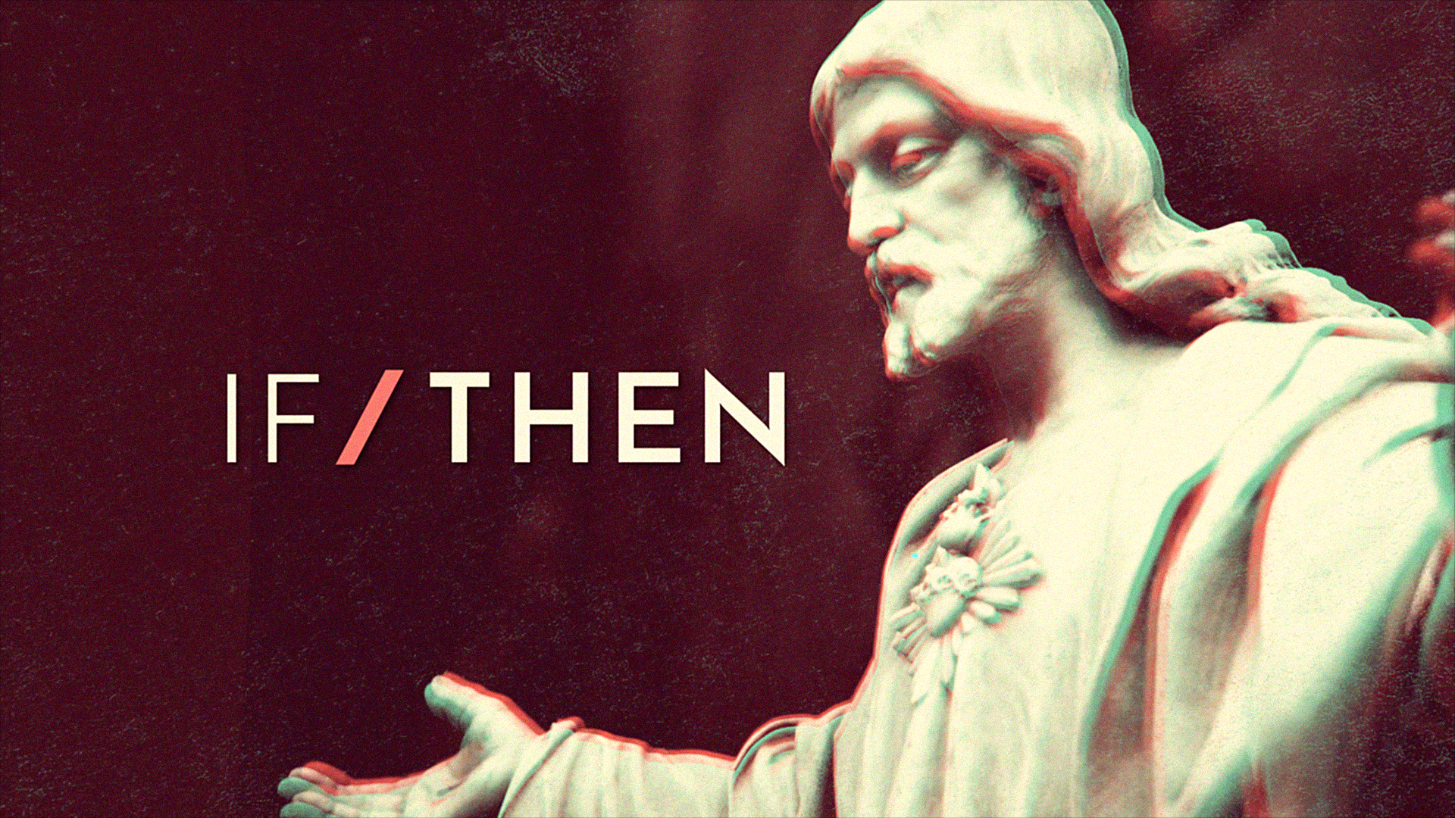
Week 1
How do you normally introduce yourself? Maybe you start with, “Hi. I’m (insert your name here).” But what comes after that? Sure, you can talk about where you go to school, or what hobbies you’re into, but that doesn’t really introduce anyone to you, just facts about you. When Jesus talked about Himself, He would make statements like, “I am the Good Shepherd” and , I am the bread of life.” As strange as they sound, these statements give us a better picture of who Jesus is. Because if He is the bread of life, then we can be satisfied in Him. In this series, we’ll discover that the way Jesus described Himself, gives us a clue into who we are as well.
Every family has a belief system. Even if your family isn’t particularly religious, chances are there are certain things that you believe about the world and certain values that you want to pass on to your children. It’s natural. And, as our students develop into adults, it’s normal for them to think about, question, and maybe even try on other beliefs they may have been exposed to outside our home. If it hasn’t happened already, there will probably come a day when your student makes a statement or asks a question that feels like it flies in the face of all you’ve taught them. And while it’s unsettling and uncomfortable for us, it isn’t necessarily a bad thing. In fact, questioning can be good. It means they’re growing.
At moments like these, it’s important to remember that, just as our students’ bodies and minds are developing, their faith and beliefs are developing too. They may go through stages or seasons of faith that look different, but that doesn’t mean it is where they will ultimately land.
One way we can help our students navigate this tricky time is to be authentic about our own faith journey. Religious or not, we all have questions and doubts we wrestle with from time to time. We all have moments that leave us feeling a little confused or unsettled about our beliefs. And the same things that have helped us through those times may be helpful for our students as well.
Maybe it’s been a while since you really wrestled with a tough question about life or maybe you weren’t sure what to do with it. That’s okay. Here are four strategies you may find helpful when you don’t have all the answers.
• Call a friend. Sometimes it’s helpful to talk through concerns with someone who is wiser, older, or simply a good listener.
• Investigate. Maybe the next time you encounter tough questions, it’s time to commit some time to reaching possible answers.
- Trust what you know. When answers are hard to come by, we can still trust the things we already know to be true. For example, I’m not the only person to ever think this way or feel this way or, I believe that God is good. So, even though this situation doesn’t seem good, I can trust that He is.
- Keep walking. Sometimes the hardest and most helpful thing to do in the face of tough doubts or questions is to simply keep going. Don’t get stuck. Keep serving. Keep loving people, and trust God to help you figure out the tough stuff over time.
Just like your teenager is still developing physically and mentally, their belief system is still under construction as well. As a result, from time to time, they may say something surprising or something that conflicts with what you believe. Don’t freak out. While it’s appropriate to guide and direct your student to what’s best for them, sometimes there’s something better. Become a professional question asker— not nagger, lawyer, or annoyer—but someone who asks questions in order to better connect. Then patiently listen as they process through their own faith and beliefs.
Responding with curiosity toward your teenager will always go further than responding with defensiveness. Ask a question or two from the list below and see where the conversation goes. Remember, do more listening than teaching, and don’t take it personally if your child doesn’t exactly reflect your beliefs. Their belief system is growing and changing, and the ultimate goal is for them to develop a faith of their own.
• That’s interesting. What’s something you read that led you to think that way?
• What’s the most memorable conversation you’ve had that led you do think the way you do?
• Can you teach me about that so I can better understand?

